Financial News Sentiment Analysis
A Comparative Study of BERT-based Transformer Models
ECL-545 S26 Natural Language Processing - Project Report

By
Brajesh Singh, Chandan Chugh, and Milind Mahajan
Visvesvaraya National Institute of Technology, Nagpur
May 2026

Abstract
This report presents a comparative study of three transformer-based approaches for financial news sentiment classification: zero-shot BERT, fine-tuned BERT, and zero-shot FinBERT. The models were evaluated on two datasets: the widely used Financial PhraseBank benchmark and an independently collected dataset comprising previously unseen financial news headlines. In this work, a bert-base-uncased model was further fine-tuned on a curated financial sentiment dataset containing more than 10,000 labelled headlines categorized into positive, negative, and neutral classes. To improve performance and handle class imbalance, training used a class-weighted cross-entropy loss, a cosine-decay learning rate schedule with a warmup, and early stopping. The best-performing checkpoint was reached at the 8th epoch (step 3440), yielding a validation accuracy of 82.15% and a weighted F1-score of 82.17%. Experimental evaluation on the Financial PhraseBank benchmark showed that the fine-tuned BERT model achieved 95.8% accuracy, while FinBERT achieved 97.6%, both substantially outperforming the zero-shot BERT baseline, which achieved only 27.4% accuracy. On the more challenging unseen financial news dataset, the fine-tuned BERT model achieved the best overall performance, with 73% accuracy and a weighted F1 Score of 71.65%. The results demonstrate that task-specific fine-tuning significantly improves generalization to real-world financial news and enables better adaptation to unseen financial headlines compared to zero-shot approaches.

1. Introduction
Financial news sentiment analysis plays an important role in areas such as algorithmic trading, market prediction, portfolio management, and financial risk analysis. Since financial text contains domain-specific terminology and context-dependent sentiment, general NLP models often struggle without adaptation to the domain. This project compares zero-shot BERT, fine-tuned BERT, and FinBERT to evaluate whether domain-specific pretraining or task-specific fine-tuning produces better performance for financial sentiment classification. The evaluation was conducted using the Financial PhraseBank benchmark dataset and a separate dataset of 1,875 real-world financial news headlines collected from live sources, not used during training.

2. Problem Statement
The objective is to classify a financial news headline or sentence into one of three sentiment categories: positive, negative, or neutral.
- Positive sentiment indicates favorable business or financial developments
- Negative sentiment reflects weak or worsening financial conditions
- Neutral sentiment represents factual information without a strong positive or negative tone.
This task is challenging because financial datasets are usually imbalanced, with neutral statements appearing much more frequently than the other classes. In addition, financial language often contains subtle context-dependent meanings, making it difficult for models to accurately interpret sentiment and generalize effectively to unseen real-world news data.

3. Dataset

3.1 Training Data - financial_sentiment.csv
The training corpus (financial_sentiment.csv) is a merged and cleaned dataset of financial news headlines and sentences compiled from multiple public sources. It contains two columns - text and sentiment - with labels normalized to lowercase: positive, negative, neutral.

Split | Samples | Positive | Negative | Neutral
Train (80%) | 4984 | ~2143 | ~847 | ~1994
Validation (10%) | 623 | ~268 | ~112 | ~249
Test (10%) | ~623 | ~268 | ~112 | ~249

Stratified splitting (80/10/10) was used to ensure label distribution is preserved across all splits. A random seed of 42 was set to ensure reproducibility.

3.2 Evaluation Set 1 - Financial PhraseBank (AllAgree)
The Financial PhraseBank dataset (Malo et al., 2014) is a standard benchmark for financial sentiment analysis. The AllAgree subset - where all annotators agreed on the sentiment label - was used as the primary evaluation benchmark. It contains 453 sentences across 114 positive, 61 negative, and 278 neutral examples.

3.3 Evaluation Set 2 - Collected Unseen Data
To assess real-world generalisation, 1,875 financial headlines were collected from live sources including Economic Times and The Hindu Business Line in April 2026. This dataset was never seen during training or validation and represents genuinely unseen data. It contains 968 positive, 555 negative, and 352 neutral examples, with labels manually assigned.

4. Models

Model | Base | Approach | Parameters
BERT (Zero-shot) | BERT-base-uncased | Fill-mask zero-shot - no fine-tuning | 110M
BERT (Fine-tuned) | BERT-base-uncased | Sequence classification head; fine-tuned on financial_sentiment.csv | 110M
FinBERT (Zero-shot) | ProsusAI/finBERT | Finance-domain pre-trained BERT; zero-shot classification | 110M

4.1 Fine-Tuned BERT
BERT-base-uncased was fine-tuned end-to-end for 3-class sentiment classification. A linear classification head was added on top of the [CLS] token representation. All 12 encoder layers were kept trainable. Class-weighted cross-entropy loss was used to compensate for class imbalance in the training set, with weights computed using scikit-learn's balanced class weighting.

5. Methodology

5.1 Pipeline Overview
The project follows a four-stage pipeline:

Stage | Script | Description
1 - Data Preparation | data_preparation.py | Load CSV, clean labels, tokenise with BERT-base-uncased tokeniser, split 80/10/10, save as HuggingFace DatasetDict
2 - Fine-tuning | finetune_bert_merged.py | Fine-tune BERT-base-uncased with WeightedTrainer, early stopping, cosine LR decay
3 - Evaluation | compare_3way.py | Run all three models on test set, compute metrics, generate charts
4 - Training Analysis | plot_training.py | Extract training logs from trainer_state.json, plot loss and metric curves

5.2 Tokenisation
Input text was tokenized using the BERT-base-uncased fast tokenizer with a maximum sequence length of 128 tokens.

5.3 Class Imbalance Handling
The training corpus exhibits a moderate class imbalance, with neutral sentences being the most frequent and negative sentences the least. To address this, class weights were computed using the balanced strategy and applied as per-class weights in the cross-entropy loss function.

5.4 Training Strategy
Fine-tuning used the HuggingFace Trainer API with a custom WeightedTrainer subclass to inject class weights into the loss computation. Gradient accumulation (2 steps) was used to achieve an effective batch size of 16 while keeping memory consumption low. Early stopping monitored validation F1 weighted with a patience of 3 epochs, preventing overfitting.

6. Training Configuration

Hyperparameter | Value | Rationale
Learning Rate | 1e-5 | Conservative rate for fine-tuning a pre-trained model
Epochs | 10 (max) | Early stopping typically triggers before completion
Batch Size | 8 (effective 16) | Gradient accumulation steps = 2
LR Scheduler | Cosine Decay | Smooth LR reduction; avoids sharp drops
Warmup Ratio | 0.10 | 10% of steps used for linear LR warmup
Weight Decay | 0.01 | L2 regularisation to prevent overfitting
Early Stop Patience | 3 epochs | Based on validation F1 weighted
Loss Function | Weighted CrossEntropy | Handles class imbalance
Optimiser | AdamW | HuggingFace Trainer default
Max Sequence Length | 128 tokens | Covers ~99% of financial headlines
Random Seed | 42 | For reproducibility

7. Training Dynamics
The training process was logged every 50 steps and evaluated at the end of each epoch. Three plots were generated from the trainer_state.json checkpoint logs. Details are provided at the end in the Appendix section.

8. Results - Financial PhraseBank
The Financial PhraseBank AllAgree test set (453 sentences) was used as the primary structured benchmark, representing clean, high-quality, professionally annotated financial text.

8.1 Overall Metrics
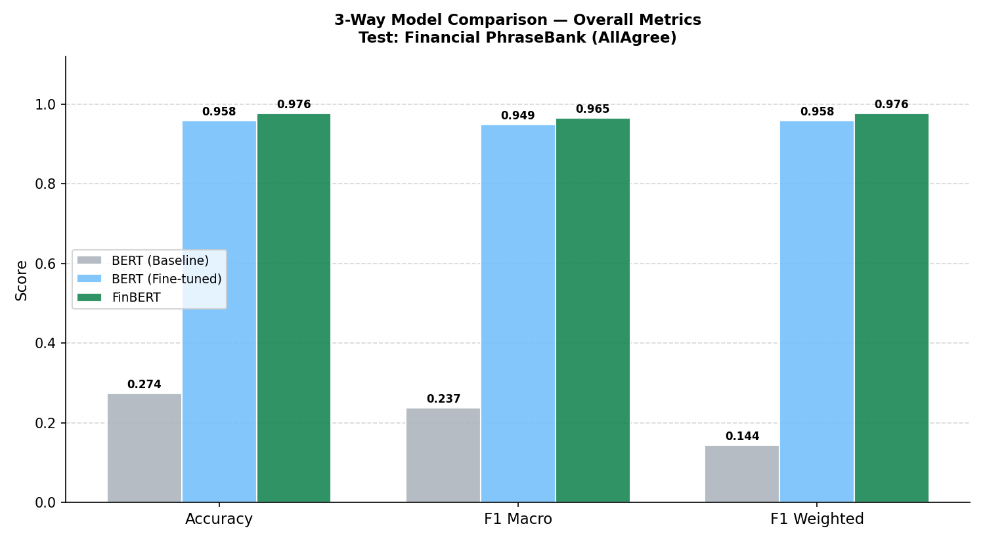
Figure 4: Overall Accuracy, F1 Macro, and F1 Weighted on the Financial PhraseBank test set.

Model | Accuracy | F1 Macro | F1 Weighted
BERT (Zero-shot) | 0.274 | 0.237 | 0.144
BERT (Fine-tuned) | 0.958 | 0.949 | 0.958
FinBERT (Zero-shot) | 0.976 | 0.965 | 0.976

8.2 Per-Class F1
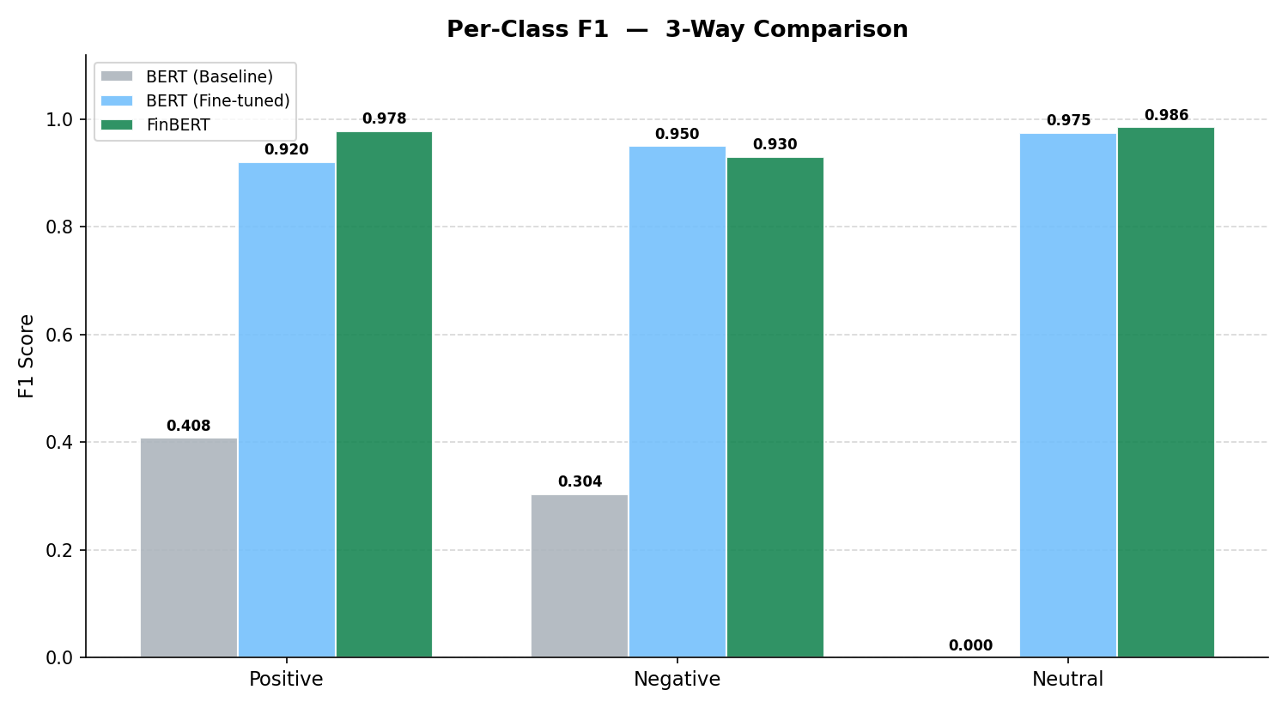
Figure 5: Per-class F1 scores on PhraseBank - BERT Baseline, Fine-tuned BERT, and FinBERT.

8.3 Confusion Matrices
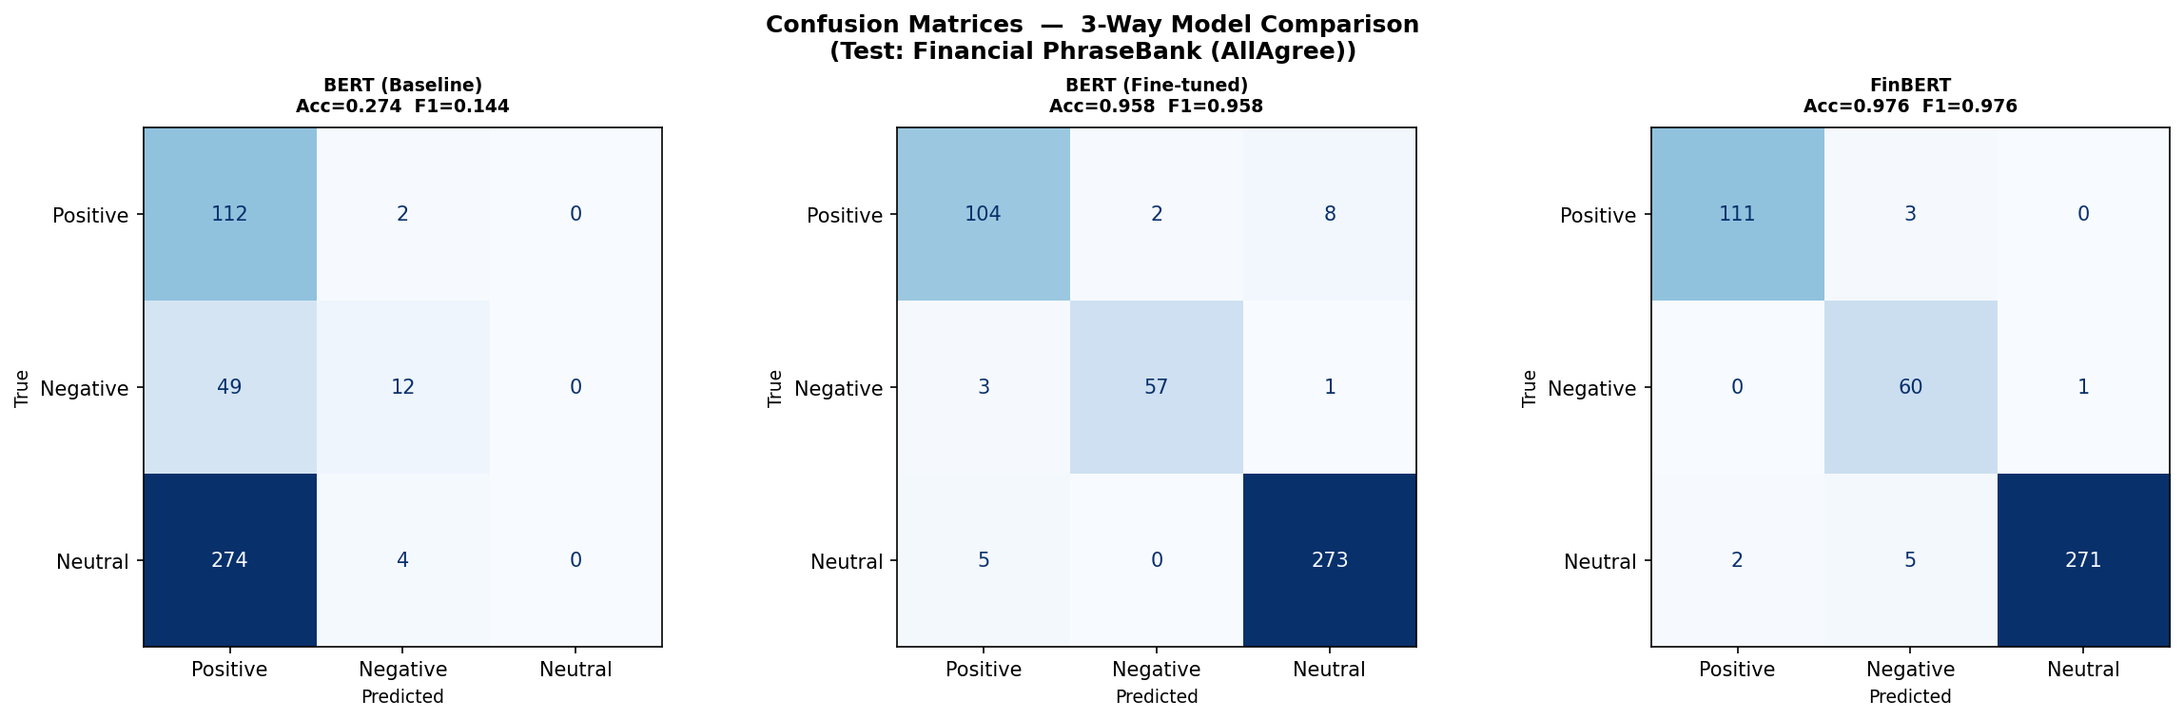
Figure 6: Confusion matrices on PhraseBank. BERT baseline misclassifies nearly everything as Positive. Both trained models show strong diagonal dominance.
The confusion matrices confirm the narrative: BERT baseline sends 274 neutral and 49 negative sentences to the Positive class - a manifestation of the positivity bias inherent in general language models. Fine-tuned BERT (104/114 Positive, 57/61 Negative, 273/278 Neutral correct) and FinBERT (111/114, 60/61, 271/278) both show tight diagonal matrices with only scattered off-diagonal errors.

8.4 Improvement Over BERT Baseline
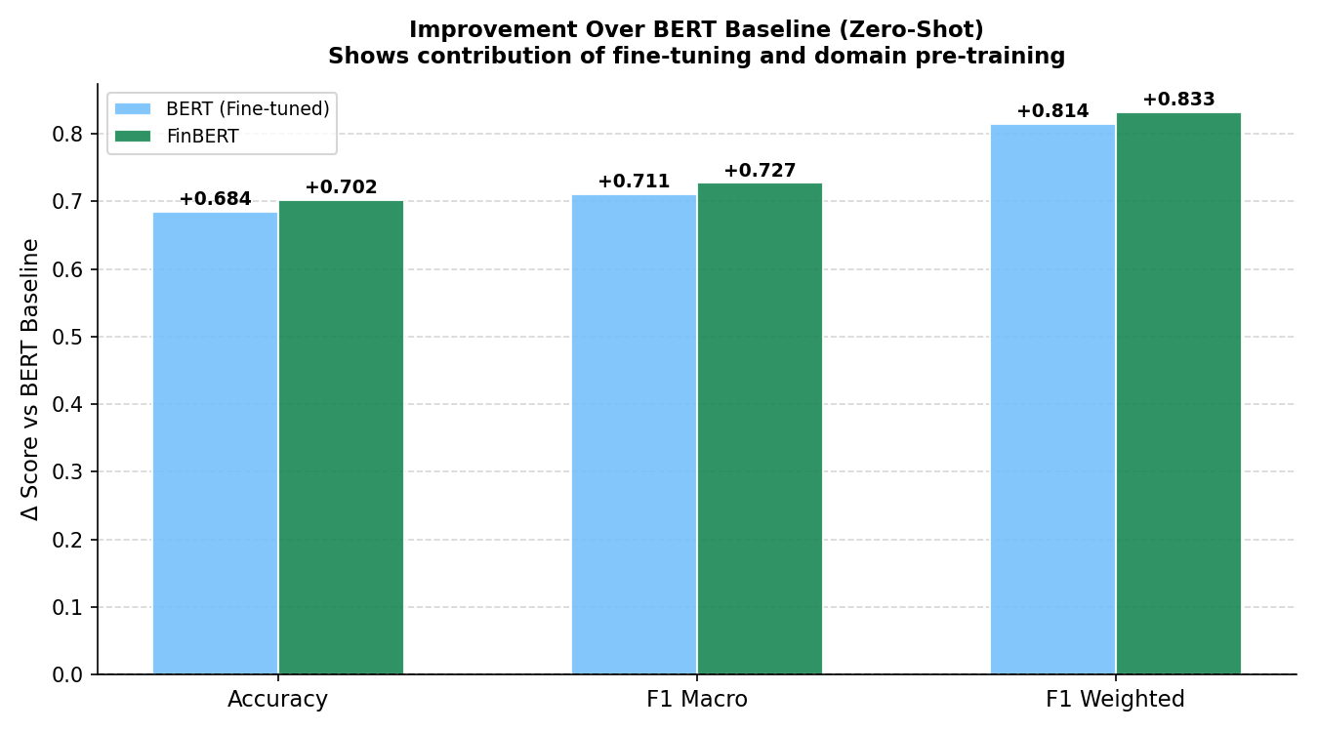
Figure 7: Delta scores over BERT zero-shot baseline on PhraseBank. Fine-tuned BERT: +0.814 F1 Weighted. FinBERT: +0.833 F1 Weighted.

9. Results - Collected Unseen Data
The collected dataset (1,875 headlines from live financial news sources) tests real-world generalization - a substantially harder challenge than the Phrase Bank benchmark due to noisier text, diverse writing styles, and longer headlines.

9.1 Overall Metrics
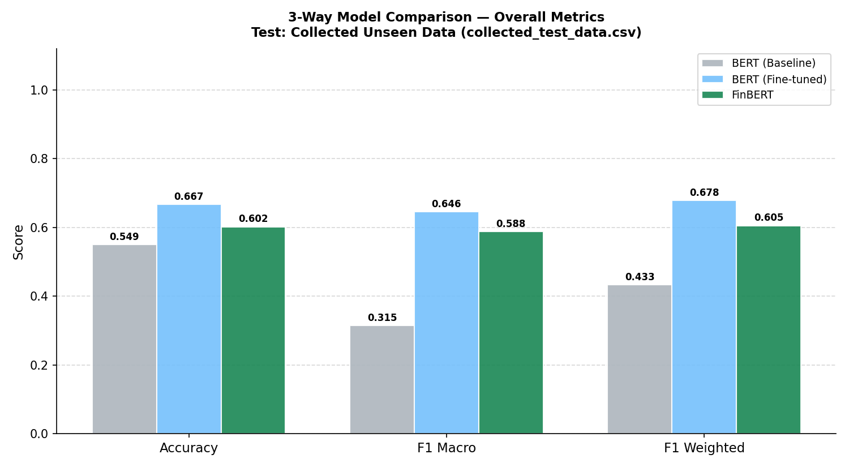
Figure 8: Overall Accuracy, F1 Macro, and F1 Weighted on the Collected Unseen Data.

Model | Accuracy | F1 Macro | F1 Weighted
BERT (Zero-shot) | 0.549 | 0.315 | 0.433
BERT (Fine-tuned) | 0.667 | 0.646 | 0.678
FinBERT (Zero-shot) | 0.602 | 0.588 | 0.605

Performance drops substantially across all models compared to PhraseBank - expected given the noisier, real-world nature of the collected data. Fine-tuned BERT achieves the highest accuracy (66.7%) and F1 weighted (67.8%), outperforming FinBERT zero-shot (60.2% accuracy, 60.5% F1 weighted) by a meaningful margin of ~7pp. This demonstrates that task-specific fine-tuning generalises better to unseen real-world data than domain pre-training alone.

9.2 Per-Class F1
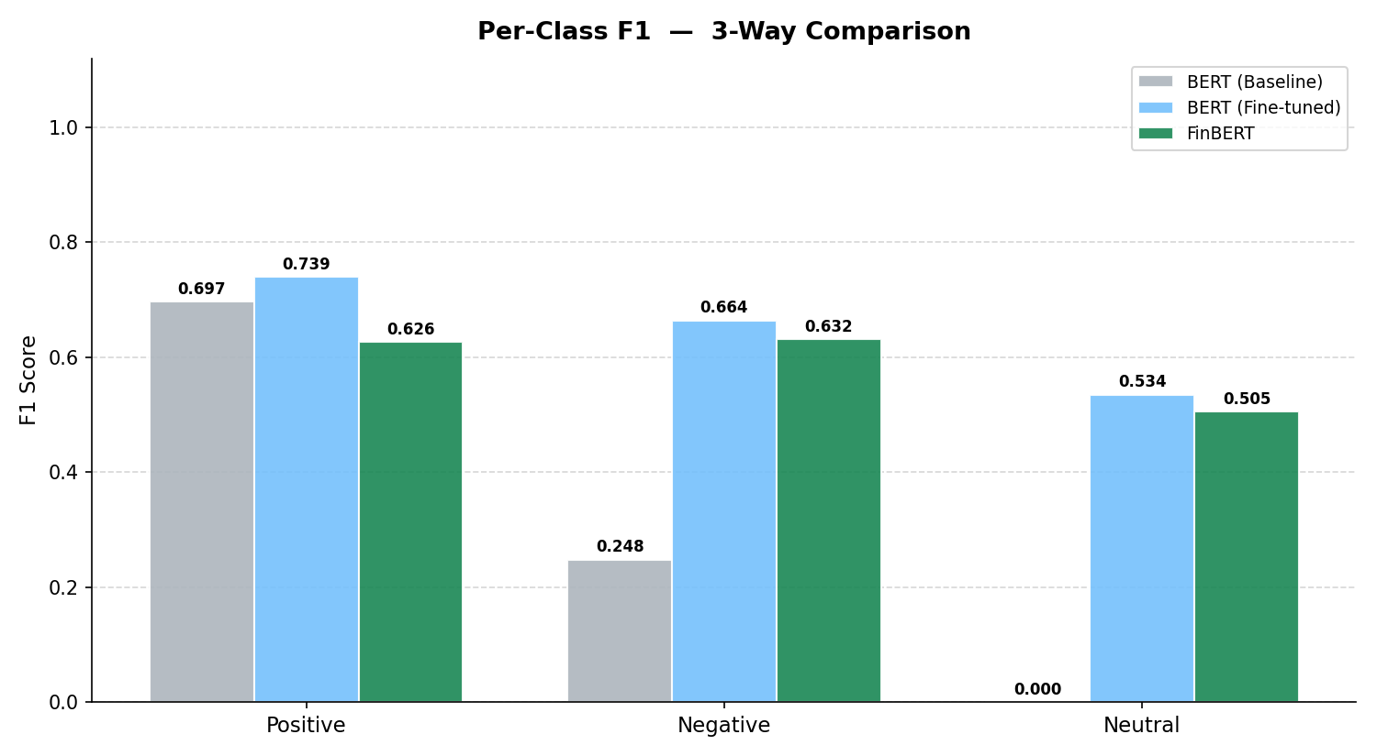
Figure 9: Per-class F1 scores on Collected Unseen Data.
The Neutral class remains the most difficult across all models. BERT baseline scores 0.0 on Neutral (predicts almost no neutral examples) while fine-tuned BERT achieves 0.534 and FinBERT 0.505. On Negative - historically the hardest class - fine-tuned BERT (0.664) substantially outperforms FinBERT (0.632) and the baseline (0.248). This advantage on minority classes is a direct result of class-weighted training.

9.3 Confusion Matrices
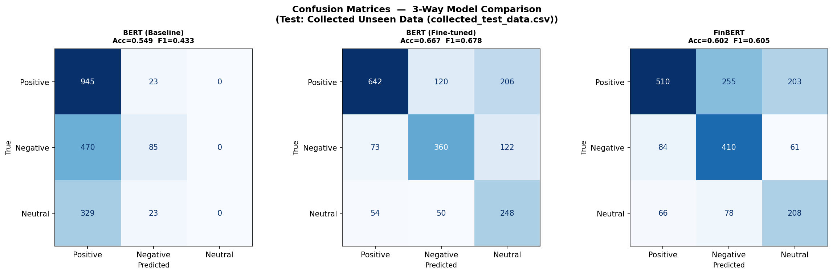
Figure 10: Confusion matrices on Collected Unseen Data. Fine-tuned BERT shows the most balanced predictions across all three classes.
The collected data confusion matrices reveal that all models still have a positive prediction bias. The BERT baseline predicts 945/968 positive correctly but only 85/555 negative and 0/352 neutral. Fine-tuned BERT shows considerably more balanced predictions: 642 positive, 360 negative, 248 neutral correctly classified. FinBERT handles negatives well (410/555) but struggles with positives (510/968) and neutrals (208/352).

9.4 Improvement Over BERT Baseline
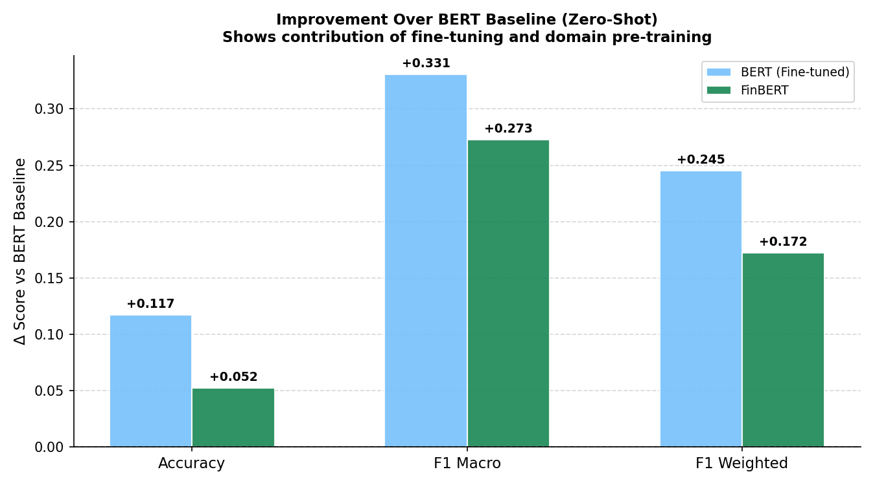
Figure 11: Delta scores over BERT zero-shot baseline on Collected Data. Fine-tuned BERT: +0.245 F1 Weighted. FinBERT: +0.172 F1 Weighted.

10. Comparative Analysis & Discussion

10.1 Benchmark vs. Real-World Performance
There is a stark contrast between PhraseBank and collected data performance. PhraseBank - being professionally annotated with high inter-annotator agreement - is structurally clean and well-suited to models trained on similar data. The ~30pp drop in accuracy for fine-tuned BERT (95.8% → 66.7%) and FinBERT (97.6% → 60.2%) when moving from curated benchmarks to collected data underscores the distribution shift between them and live financial news.

10.2 Fine-Tuning vs. Domain Pre-Training
A key finding of this study is that fine-tuning on task data outperforms domain pre-training (FinBERT) on the harder generalization task. While FinBERT marginally leads on the clean PhraseBank benchmark (97.6% vs 95.8%), fine-tuned BERT leads on collected unseen data (66.7% vs 60.2%). This suggests that task-specific signal - knowing the label space and seeing balanced training examples - is more valuable for generalisation than domain-specific linguistic representations alone.

10.3 Class Imbalance and Neutral Prediction
The Neutral class is consistently the most difficult to predict. BERT baseline completely fails (F1 = 0.0), while even fine-tuned BERT only achieves 0.534 on collected data. Neutral sentiment in financial news is inherently ambiguous - factual reporting can appear positive or negative depending on context. The class-weighted loss provides meaningful but incomplete mitigation; future work could explore data augmentation for neutral examples or auxiliary tasks.

10.4 Validation Loss Divergence
The observation that validation loss increases from epoch 4 while F1 metrics continue improving (peaking at epoch 8) is noteworthy. This divergence is explained by calibration: as training progresses, the model assigns increasingly high confidence to correct predictions, which raises the cross-entropy loss even as classification accuracy improves. This highlights the importance of using task-relevant metrics (F1) rather than validation loss alone for model selection in imbalanced classification.

11. Conclusion
This project demonstrates that fine-tuning the BERT base uncased model on a curated financial sentiment dataset yields a robust classifier that generalizes better to real-world financial news than zero-shot FinBERT. While both models achieved over 95% accuracy on the Financial PhraseBank dataset, the fine-tuned BERT model performed significantly better on unseen real-world data, achieving 66.7% accuracy and a weighted F1-score of 67.8%, compared to FinBERT’s 60.2% accuracy and 60.5% weighted F1-score.
The results also highlight the importance of using metric-based early stopping, especially for imbalanced classification tasks where validation loss alone may not reflect actual performance. Applying class-weighted loss further improved predictions for minority sentiment classes such as negative and neutral.
Future work may include fine-tuning FinBERT on the same dataset, training on larger Indian financial news datasets, exploring ensemble techniques, and incorporating broader contextual information beyond individual headlines.

12 References
[1] Devlin, J., Chang, M.-W., Lee, K., & Toutanova, K. (2019). BERT: Pre-training of Deep Bidirectional Transformers for Language Understanding. NAACL-HLT 2019.
[2] Malo, P., Sinha, A., Korhonen, P., Wallenius, J., & Takala, P. (2014). Good Debt or Bad Debt: Detecting Semantic Orientations in Economic Texts. Journal of the American Society for Information Science and Technology, 65(4), 782–796.
[3] Yang, Z., Dai, Z., Yang, Y., Carbonell, J., Salakhutdinov, R., & Le, Q. V. (2019). XLNet: Generalized Autoregressive Pretraining for Language Understanding. NeurIPS 2019.
[4] Araci, D. (2019). FinBERT: Financial Sentiment Analysis with Pre-trained Language Models. arXiv preprint arXiv:1908.10063.
[5] HuggingFace Inc. (2023). Transformers: State-of-the-Art Machine Learning for PyTorch, TensorFlow, and JAX. https://github.com/huggingface/transformers

Appendix

1. Software & Dependencies
Package | Version | Purpose
PyTorch | >=2.2.0 | Deep learning framework; GPU training
Transformers (HuggingFace) | >=4.40.0 | BERT, FinBERT, Trainer API
Datasets (HuggingFace) | >=2.19.0 | DatasetDict, tokenised splits
scikit-learn | >=1.4.0 | Metrics, class weight computation, train/test split
pandas | >=2.1.0 | CSV loading and preprocessing
numpy | >=1.26.0 | Array operations and metric computation
matplotlib | >=3.8.0 | Chart generation
accelerate | >=0.30.0 | HuggingFace Trainer multi-GPU support
safetensors | >=0.4.0 | Efficient model weight serialisation

2. Models

2.1 BERT Zero-Shot Baseline

The vanilla BERT-base-uncased model was applied in a fill-mask zero-shot configuration. No task-specific fine-tuning was performed. This model serves as the lower-bound baseline, representing the capability of a general-purpose language model without any financial domain adaptation or training signal.

2.2 FinBERT Zero-Shot

ProsusAI/finBERT is a BERT model further pre-trained on a large corpus of financial text (Reuters, financial news, earnings reports). It was applied in zero-shot mode using its native classification head, without any additional fine-tuning on our dataset. This model tests whether domain-specific pre-training alone is sufficient for strong performance.

3. Training Dynamics

3.1 Training Loss
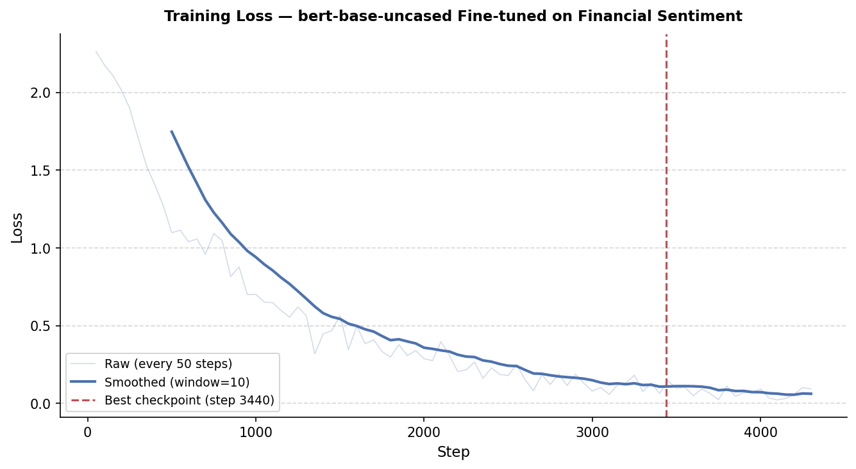
Figure 1: Training loss vs. step - raw (every 50 steps) and smoothed (window=10). Best checkpoint at step 3440 marked in red.
Training loss begins at approximately 2.25 and decreases steeply in the first 500 steps as the model rapidly adapts its classification head. The descent continues smoothly to approximately 0.08 at step 4300, indicating effective learning. The best checkpoint (step 3440) falls well within the convergence zone, confirming the model had adequately fit the training data before overfitting became a concern.

3.2 Validation Loss
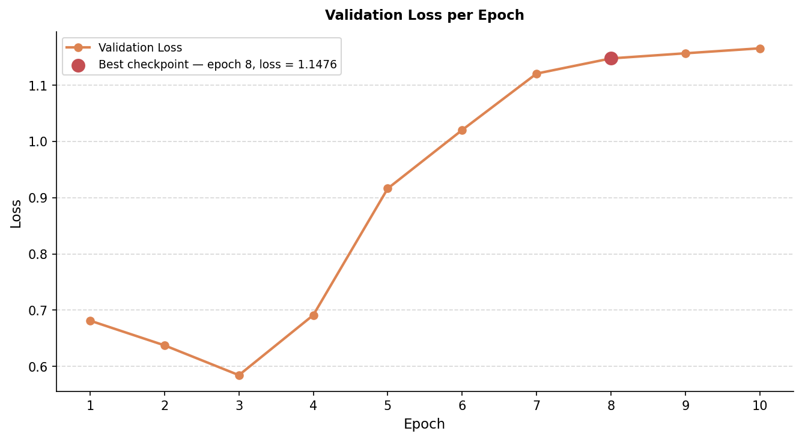
Figure 2: Validation loss per epoch. Note the divergence from epoch 4 onwards while F1 metrics continue to improve.
An important observation is that validation loss reaches its minimum at epoch 3 (0.587) and then rises steadily to 1.148 by epoch 8. This behaviour, in which loss increases while F1 metrics improve, is consistent with a model that becomes more confident in its predictions over time - the probability mass shifts toward the correct class even as the absolute loss increases. Early stopping was correctly configured to use F1-weighted rather than validation loss, allowing the model to reach its performance peak.

4. Limitations
- Label quality for collected data: manual labelling of 1,875 headlines introduces subjectivity; sentiment in financial text is often context-dependent and ambiguous.
- Dataset size: the training corpus (~10,000 samples) is small relative to industrial-scale fine-tuning datasets; larger corpora could substantially improve generalisation.
- Zero-shot BERT limitations: the fill-mask approach for zero-shot classification is a weak baseline that does not represent the true capability of BERT for classification tasks.
- No ensembling: combining fine-tuned BERT and FinBERT predictions could yield better performance than either model alone.
- Domain drift: the collected data spans April 2026 - potential shifts in financial language, company names, and market conditions may not be captured in the 2025 training data.

